Organelle and structures
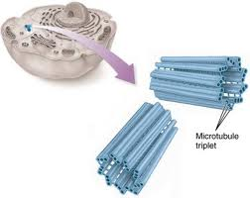
Centrioles-Is a small organelle that is part of the cytoplasm. And they are mostly found in animal cells. It is found near the nucleus and its purpose is to aid in mitoses. It mainly aids in the step of cell division. It is used to help form spindle fibers for the new cell. Also helps for the tall of the sperm.

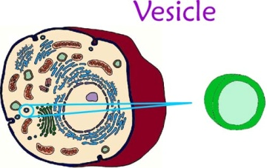
Vesicles-is a bubble like membrane that transports materials around the cell.
It transports materials to certain organelles and transports stuff out of them.

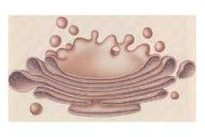
Golgi apparatus-is the organelle that process sort and deliver protein. To the parts of the cells that need them.

