Organelles and Structures
The Cytoskeleton gives the cell structure and shape. It has microtubules, which assists in organelle movement. It also has microfilaments, which enable cells to move and divide. The Microfilaments are small, threadlike structures, and Microtubules are hollow, long tubes.
The green is the Cytoskeleton

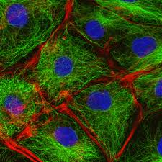
Cell membrane forms a boundary between the outside world, and the cell. It also controls the passage of materials in and out of the cell. It is the outermost layer of the animal cell, and the second layer of plant cells.
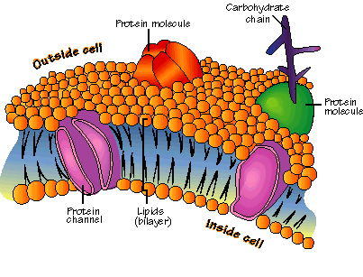
Mitochondria gives energy to the cell. It is shaped like a bean.
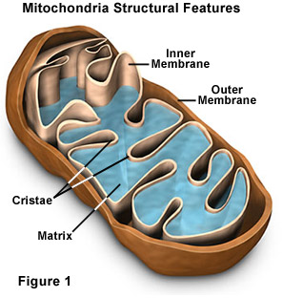

The Chloroplast converts solar energy to chemical energy using photosynthesis. It’s shape is Oval-shaped, and is green. They are only found in Plant cells.
